* Describe how the images chosen meet the client brief

I have used images of children playing to give the site a good feel to inspire donation. The information used is to help viewers understand your charity supports children and their needs. Images have been modified and resized to optimise the load time of the site so it loads quickly.

* How have your modified images better suited the web medium

Images resized to best fit the site size and reduce the total size of the file system

* What rationale was used when choosing the file format for each image

JPG was used to conserve disk space making the site load faster

* Note Source for all images, including copyright and/or license requirement(s)

Image 1 – children-fingers

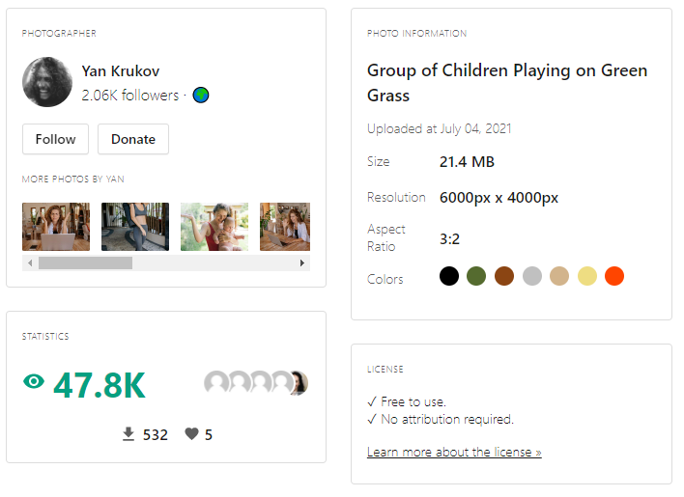

Image 2 – donations

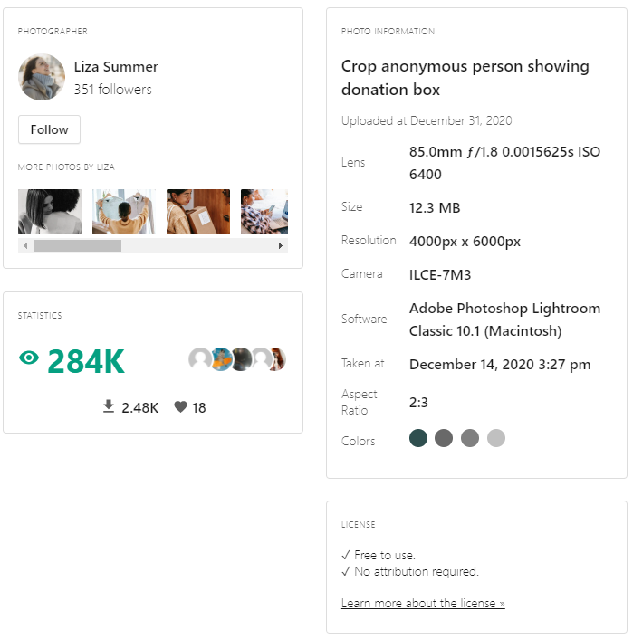

Image 3 – phone

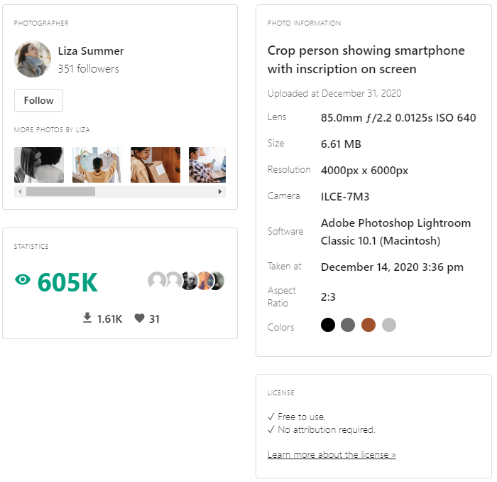

Image 4 – man

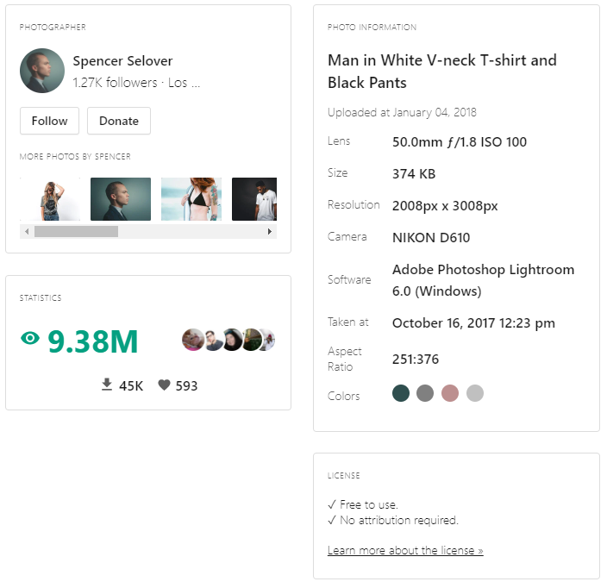

Image 5 – old_man

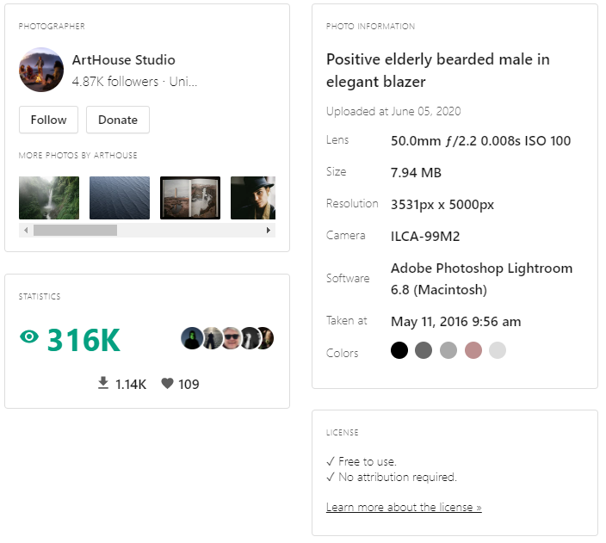

Image 6 – woman

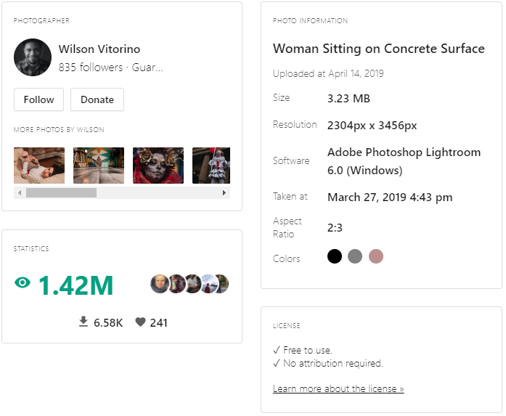

Image 7 – Classroom

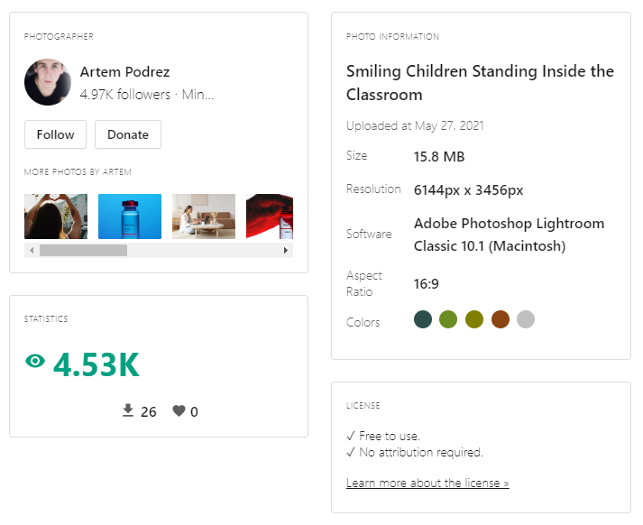

* Sell your design to client (Teacher). Describe how it meets client objectives